# Durable Furnitures

Knowlton

## Cherry Moon China Cabinet & Sideboard 51inches

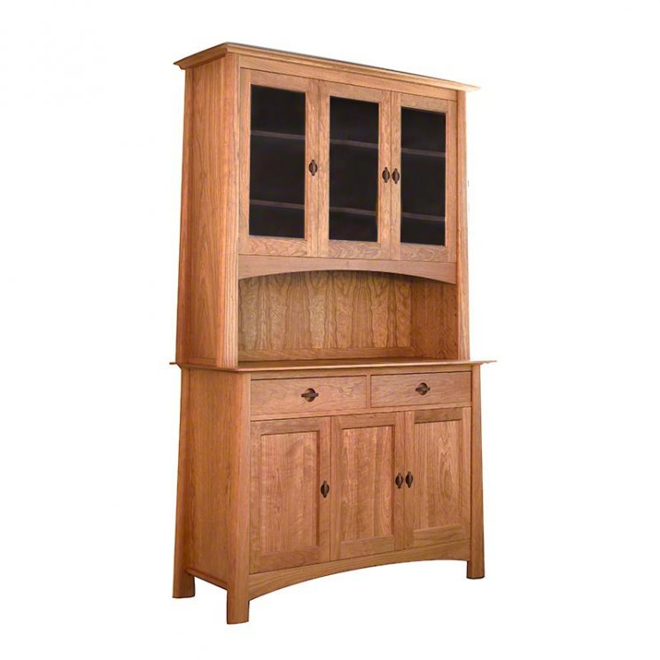

This piece features wonderful contemporary Asian styling as well as plenty of extra storage space. Showcase all your treasures behind the glass doors. Our dining room furniture is handmade from carefully selected natural hardwoods grown in sustainable forests. It is handcrafted by Vermont furniture craftsmen to produce high quality piece furniture for your upscale green home